Rental Agreement for inReach Communicator
Needs to be signed and sent to the Club along with a cheque of £100.

The unit is available for nearly all trips where communication might be otherwise compromised. It can be useful not only on expeditions but wherever there are cell phone black spots – plenty of those in Scotland and the Alps. |  | 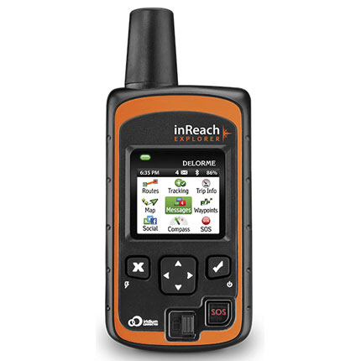
Terms and Conditions: | - The unit must be indemnified against loss or damage. Replacement cost is £265. Self-insurance is acceptable, provided the renter agrees to cover the cost of the above.  - The invoice from Delorme is itemised but only comes in once a month. Renter’s deposit will be returned after the Delorme invoice for the relevant month comes in.  - Rent and usage will be deducted from the deposit before it is returned.  - The cost of secure (insured) postage will be deducted from the deposit or the unit can be collected from the Club.  - Deposit is £100. Rent is £10 per week during the time it is in the renter’s possession. Return postage is at renter’s cost or unit can be handed back to the Club.  - Approximate usage cost is 7p per way-point, 35p per message sent and / or received.  - The renter agrees to indemnify the club in respect to all charges associated with the unit, excluding the standard monthly contract rental amount, during the time it is in the renter’s possession. If such amounts, along with the £10 weekly rental due to the Club, exceed the deposit amount, the renter will need to pay the full additional amount to the club.  - The renter accepts that electronic devices can be unreliable, and agrees not to hold the Club responsible for any failure of the unit to work as intended, whatever the circumstances.
Unit IMEI number: | No 1 / 300434060361600  No 2 / 300434060364840
Renter’s contact details: | Name / address / mobile number _________________________________________________________  _________________________________________________________  AC member no ____________________________________________
Rental period: | From / to ____________________________________________
Expedition/Trip details:
Posting details: | (only if the unit is sent by mail)  Address ____________________________________________  ____________________________________________  ____________________________________________
Emergency Contacts: | Contact 1 mandatory  Name / surname __________________________________________  Relation __________________________________________  Phone 1 __________________________________________  Phone 2 __________________________________________  Email __________________________________________  Contact 2 mandatory  Name / surname __________________________________________  Relation __________________________________________  Phone 1 __________________________________________  Phone 2 __________________________________________  Email __________________________________________
Agreement: | I agree to the terms and conditions.  Date ____________________ Signature _______________________

 | For office use only
Deposit received: | The AC has received the £100 as deposit - condition of rental agreement  Date ____________________ Signature AC _____________________

 | (for office use only)
Returned: | The unit(s) was/were returned on:  Date ____________________
Deposit returned amount: | The amount of ____________________  Was returned on: Date ____________________

